BERNHARD LACKNER
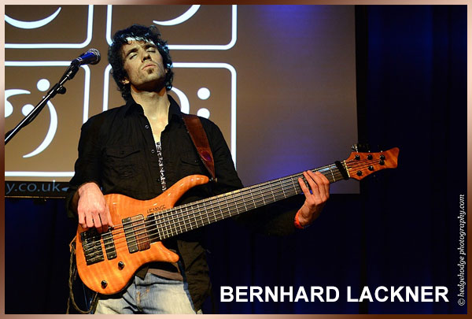
Austrian bassist/composer Bernhard Lackner worked with artists including Mino Cinelu, Adam Holzman, Marco Minnemann, Horacio El Negro Hernandez, Adam Nitti, Trip Wamsley, Florian Bramböck, Steve Cunningham, Christian Wegscheider, Franz Hackl, Jeff Coffin, Derico Watson, Chester Thompson, performed at festivals such as Eurobassday (Italy), at the Outreach Jazzfestival (Austria), at the Namm Bass Bash (USA), at the National Guitar Workshop (USA), the London Bass Guitar Show (England), Pasadena Bassday (USA), at the Groznjan Drumcamp (Croatia), Bassday UK (England) and many more.

In 2006 he released his debut album "Those Days", in 2009 his 2nd album "In Between", in 2010 his exercise book "Plucking Hand Workout" and in 2011 he followed up with his 3rd album "Stories From Home".

